Technical Design

Team: | Phantom | ITN: | 3 |  |  | Solution Design
 |  | Pipeline(s):
  MH4

Solution Design 1
Pipeline(s): 1
1 Introduction 1
1.1 Link to Requirements Document 1
1.2 Requirements 1
User Story 1
2 Design Discussion 2
2.1 Use Case 2
2.2 Class Diagrams 3
3 Implementation 4
3.1 Files 4
4 Testing Considerations 13
5 Screenshots 14

Introduction
This is a web-based application used to manage the contacts for a firm. The contacts are stored in a secure location on an internal server and the user is able to log in to the system using their access details.
The user can perform CRUD operations based on the privileges provided to them by the administrator.

Link to Requirements Document
https://jira2.cerner.com/browse/DEVACDMY-5165

Requirements

User Story
User Story ID | MH4
Story | View list of contacts
Description | The user is able to see all the contacts in grid/list layout that are saved in the database.

Design Discussion

2.1 Use Case
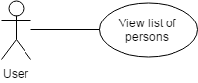
Figure 1 Use case for viewing list of contacts

2.2 Class Diagrams
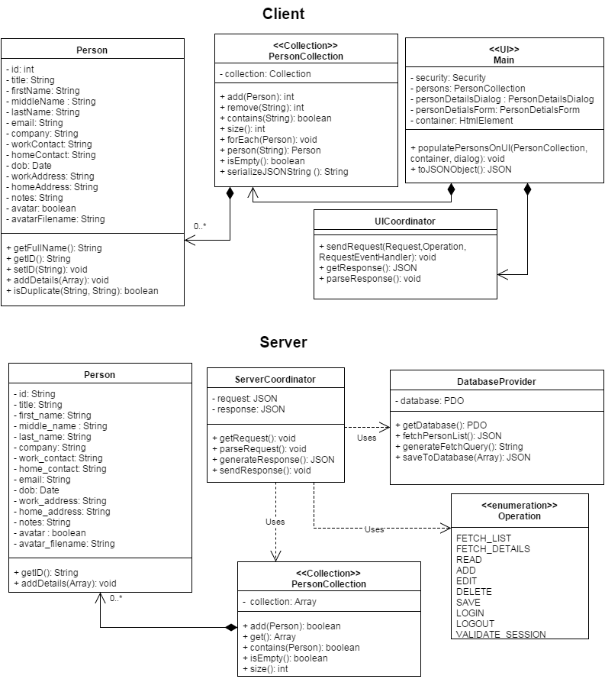
Figure 2 Class Diagram for listing contact

Implementation

The main objective is to allow the user to view the list of contacts saved in the database. The implementation details are as follows:

- The client sends a request for getting a list of contacts using an asynchronous request using AJAX
- The server receives the request and prepares a SQL statement to fetch the list of contacts.
- The SQL query is executed and the list of contacts is obtained in an array.
- If the array is empty, ‘status’ is set to failure and a message is sent to notify the user that there are no contacts in the database.
- If the array is not empty, it is converted into JSON form and sent to the client. The JSON consists of three keys namely :
- “status” : Can be success, failure or error
- “message” : Contains a message to notify the user about relevant information
- “data”: Contains the data that is sent by the server
- The client receives the JSON data and populates the list of contacts onto the HTML page.

Files
3.1.1 JAVASCRIPT

File | scripts/js/Main.js
Description | This class creates the objects for the application and sets up the click and submit events. It directly deals with UI elements to implement business logic.
Pseudo Code | function populatePersonsOnUI(personCollection, container, dialog){  if(personCollection.isEmpty()){  $('#message').html('No contacts found');  }else{  container.html('');  personCollection.forEach(function(person){  var id = person.getID();  var fullName = person.getFullName();  // generate Html box  var box = generateBoxHtml(id,fullName);  // add contact element to html  container.append(box);  });  }  }
Passive (Yes/No) | Yes

File | scripts/js/Request.js
Description | This class contains the requested operation from a particular user and the parameters required for the operation.
Passive (Yes/No) | Yes

File | scripts/js/RequestEventHandler.js
Description | This class is an interface for the functions to be fired depending upon the resulting event of the request.
Pseudo Code | Class RequestEventHandler {  function success();  function failure ();  function error();  function complete();  function beforeSend();  }
Passive (Yes/No) | Yes

File | scripts/js/User.js
Description | This class is the definition of a real-user of the application and contains user-related info like username, name, priveleges etc.
Passive (Yes/No) | Yes

File | scripts/js/UICoordinator.js
Description | This class is responsible for sending an operating request generated from the current user to the server. The request sent is asynchronous and is implemented using AJAX.
Pseudo Code | function sendRequest (request, eventHandler, scriptName){  request = this.toJSONText(request);  $.ajax({  type: "POST",  url: "scripts/php/"+scriptName+".php",  data: request,  dataType: "json",  success: function(response){  if(typeof eventHandler.success === 'function'){  eventHandler.success(response);  }  },  error: function(XMLHttpRequest, textStatus, errorThrown) {  if(typeof eventHandler.error === 'function'){  eventHandler.error(XMLHttpRequest, textStatus, errorThrown);  }  },  failure:function(response){  if(typeof eventHandler.failure === 'function'){  eventHandler.failure(response);  }  },  complete: function(){  if(typeof eventHandler.complete === 'function'){  eventHandler.complete();  }  },  beforeSend:function(){  if(typeof eventHandler.beforeSend === 'function'){  eventHandler.beforeSend();  }  }  });  }
Passive (Yes/No) | Yes

File | scripts/js/Operation.js
Description | This class defines the constants by which the different operation are identified throughout application
Pseudo Code | class Operation = {  const FETCH_LIST : 'fetchList',  const FETCH_DETAILS : 'fetchDetails',  const READ : 'read',  const ADD : 'add',  const EDIT : 'edit',  const DELETE : 'delete',  const SAVE : 'save',  const LOGIN : 'login',  const LOGOUT : 'logout',  const VALIDATE_SESSION : 'validateSession'  }
Passive (Yes/No) | Yes

File | scripts/js/Person.js
Description | This class is a representation of an actual person with person details defining the state and functions defining the behavior of the person.
Pseudo Code | class Person(id){  this.id = id;  // default values  this.title = '';  this.firstName = '';  this.middleName = '';  this.lastName = '';  this.email = '';  this.company = '';  this.workContact = '';  this.homeContact = '';  this.dob = '';  this.workAddress = '';  this.homeAddress = '';  this.notes = '';  this.avatar = 'no';  this.avatarFilename = '';  this.getFullName = function(){  var name = "";  if (this.firstName != "") name += this.firstName + " ";  if (this.middleName != "") name += this.middleName + " ";  if (this.lastName != "") name += this.lastName + " ";  return name.trim();  }  this.addDetails = function(fields){  // for each key in array add to this['fieldname']  for(var field in fields){  if(fields[field] == null) fields[field]="";  this[field] = fields[field];  }  }  this.getID = function(){  return this.id;  }  this.setID = function(id){  this.id = id;  }  /** return which of the email or workContact is duplicate **/  this.isDuplicate = function(email, workContact){  if (this.workContact.toUpperCase() == workContact.toUpperCase())  return 'workContact';  else if(this.email.toUpperCase() == email.toUpperCase())  return 'email';  return undefined;  }  }
Passive (Yes/No) | Yes

File | scripts/js/PersonCollection.js
Description | This class is an implementation of the Collection class adapted to contain a collection of Person objects. It has methods like add(), remove(), contains(), size() etc.
Pseudo Code | function PersonCollection(){  this.collection = new Collection();  this.add = function(person){  this.collection.add(person.getID(), person);  return this.collection.getCount();  }  this.remove = function(id){  this.collection.remove(id);  return this.collection.getCount();  }  this.contains = function(id){  return this.collection.contains(id);  }  this.size = function(){  return this.collection.getCount();  }  this.forEach = function(block){  this.collection.forEach(block);  }  this.person = function(id){  return this.collection.item(id);  }  this.isEmpty = function(){  return this.collection.isEmpty();  }  this.serializeJSONString = function(){  return this.collection.serializeJSONString();  }  }
Passive (Yes/No) | Yes

3.1.3 PHP

File | scripts/php/PersonCollection.php
Description | This class is stores the list of persons in a collection object and parses it into a JSON form to be sent to the UI..
Pseudo Code | class PersonCollection{  private $pCollection;  function __construct(){  $this->pCollection = array();  }  function add($persons){  $this->pCollection = $persons;  }  function get(){  return $this->pCollection;  }  function contains($id){  foreach($this->pCollection as $person ){  if($person->id == $id)  return true;  }  return false;  }  function isEmpty(){  if($this->pCollection) return true;  return false;  }  function size(){  return sizeof($this->pCollection);  }  }

File | scripts/php/DatabaseProvider.php
Description | This class is the provider of database and various procedures on the database.
Pseudo Code | function fetchPersonList(){  global $file;  $operation = 'list';  $pCollection = new PersonCollection();  try  {  $sql = $this->generateFetchQuery();  $stmt = @$this->database->prepare($sql);  // execute the prepared statement  @$stmt->execute();  $numResults = $stmt->rowCount();  $rows = array();  // if no contacts are found  if($numResults == 0){  $status = 'failure';  $message = 'No contacts found';  }elseif ($numResults > 0){  $status = 'success'; $message = $numResults .' contacts found';  }  /* Add row to json one at a time */  while($row = $stmt->fetch(PDO::FETCH_ASSOC)){ $rows[] = $row;  }  $pCollection = new PersonCollection();  $pCollection->add($rows);  }  catch(Exception $e){  $status = 'error';  message = $e->getMessage() .' Unable to process your request.';  }  return json_encode(array(  'status' => $status,  'message' => $message,  'data' => array(  'persons' => $pCollection->get()  )  ));  }

File | scripts/php/Operation.php
Description | This class defines the constants by which the different operation are identified throughout application
Pseudo Code | abstract class Operation{  const FETCH_LIST = 'fetchList';  const FETCH_DETAILS = 'fetchDetails';  const READ = 'read';  const ADD = 'add';  const EDIT = 'edit';  const DELETE = 'delete';  const SAVE = 'save';  const LOGIN = 'login';  const LOGOUT = 'logout';  const VALIDATE_SESSION = 'validateSession';  }

File | scripts/php/ServerCoordinator.php
Description | This class is responsible for getting operation requests and parsing the request. The appropriate response is generated and passed onto the UI client.
Pseudo Code | class ServerCoordinator{  private $request;  private $response;  function getRequest(){//.. do something }  function parseRequest(){  $userName = $this->request->username;  $operation = $this->request->operation;  $params = $this->request->params;  switch($operation){  case Operation::FETCH_LIST :  $dbProvider = new DatabaseProvider();  $this->response = $dbProvider->fetchPersonList();  break;  }  }  function generateResponse(){//.. do something }  function sendResponse(){//.. do something }  }

Testing Considerations
Navigate to the home.html and follow the steps given below for each test case.

#Test Cases | Test Steps | Expected Results
TC 1 | - Navigate to home.html | The list of contacts are displayed in a grid layout.
TC 2 | - Remove all contacts from the database  - Navigate to home.html | A message shows saying “No contacts found”.
TC 3 | - Shutdown SQL server  - Navigate to home.html | A message shows saying “We cannot process your request. Please try again later”.

Screenshots

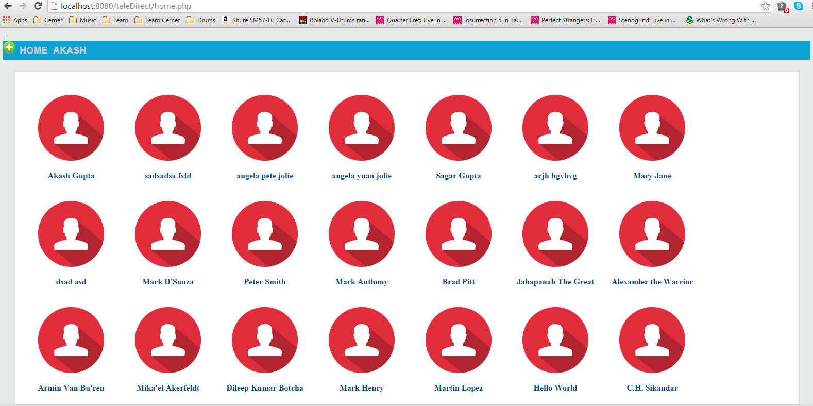
Figure 3 View list of contacts

